
Making the case for Contract Management

A White Paper
Version 1.1

Author: Shaun Cassidy
Original Date: August 2020
Updated: September 2020
Version: 1.1

Making the case for Contract Management – Version 1.1 Copyright 2018 Four Business Solutions Ltd
The copyright of this document and the contract considerations described herein and provided herewith are the property of Four Business Solutions Ltd. No part of this publication or the computer software may be reproduced, transmitted, transcribed, stored in a retrieval system, or translated into any human or computer language, in any form or by any means without the express written permission of Four Business Solutions Ltd.
118 Pall Mall
London
SW1Y 5EA Tel: +44 (0)800 625 0025
email: info@four.co.uk
Change Record

Date | Author | Version | Change Reference
 | Shaun Cassidy | V1.0 | Draft
 | Shaun Cassidy | V1.0.1 | Includes changes post initial review
 | Lesley Jessiman | V1.0.2 | Amendments following internal review
 | John OBrien | V1.0.3 | Further draft updates
 | Bala Sivagurunathan | V1.0.4 | Technical team review and update.
 | Shaun Cassidy | V1.1 | Draft approval and publish

Reviewers

Name | Position
Shaun Cassidy | Technical Director
John OBrien | Director
Bala Sivagurunathan | Development Manager
Lesley Jessiman | Research & Technical Author

What’s the bottom line?
You can’t escape contracts during these days of crushing compliance, litigation and stressful deadlines. One thing that can help you navigate these untested waters is contract management software, enhanced by the latest technology – artificial intelligence (AI), machine learning (ML) and business process automation. Whether or not you know them as more than mere tech terms, they’re here to stay and they’re fast becoming an integral part of the systems we currently use.

The detail….
Against a backdrop of global uncertainty – post GDPR – compliance and regulation are becoming increasingly onerous for most businesses. Unsurprisingly, there’s corresponding focus on watertight contracts, which has brought contract management to the fore.

What’s the contract management challenge we face in 2020?


In this post-pandemic age, the obvious advantages of remote working are starting to impact daily life and the race to harness technological advance to enhance new working practices has taken hold.

We’re largely familiar with the terms artificial intelligence (AI) and machine learning (ML) – they’re frequently bandied about and most of us would probably vaguely reference robots and smart fridges if we were pressed to explain what we understand by these terms. AI, ML and automation are synonymous with digital advance and for many define the age of transformation. So far so what?
The cradle to the grave
Contract lifecycle management – ‘the cradle to the grave’ lifecycle – is easily the most tangible and dramatic benefit of leading contract management software, and it gives organisations like yours greater transparency over your contracts – offering an undoubted opportunity to maximise value, even from existing contractual arrangements. Advanced contract management software supports:
- fast contract drafting with template libraries
- a secure repository
- version control
- easy collaboration
- electronic approvals and signing.

Although contract management software itself is not new, the capabilities it now offers are. In a bid to offer improved contract lifecycle management (CLM), innovative tech trends are being integrated in contract management software with significant improvements to the software itself, so that the user journey is cleaner, simpler and finely tuned to your individual business, ultimately with potential benefits to corporate ROI.
What difference can they actually make?
When it comes to these new technologies we can see:
- easy accessibility
- accurate reporting
- increased productivity
- quick and easy drafting and negotiation
- improved compliance
- reduced risk
- cost efficiency.
So with such undoubted benefits why isn’t everyone investing?
If you use contract management software on a daily basis, proven benefits are self-evident. If you don’t, what can you do to convince management to invest in this new technology? For medium-sized to large businesses, if you can create a strategic value proposition – which also lines up with clearly defined and recognised business goals – you’re well on the way to supporting your recommendation. And a business case that can demonstrate ROI should seal the investment.


Contract lifecycle management is everyone’s friend
If you’re a frequent user of CMS, you know all about the benefits of contract lifecycle management (CLM). If not, you can present the benefits of each corporate requirement to your decision makers, identify all the different types of users and explain how the tools you recommend address your specific user challenges.
Selecting the right system – the litmus test
To help cherry pick the best software for your business needs, consider the following:
Requests: When it comes to requesting new contracts, do you have a standardised, permissions-based process for your customers, suppliers and stakeholders?
Authoring: If you use standard templates for fast contract drafting, is it easy to make changes via editing, drag and drop and other time-saving capabilities?
Negotiations: Do all your different users – whether they’re employees, customers or suppliers – have real-time access to these contracts? Can you easily compare different versions and review changes during negotiations?
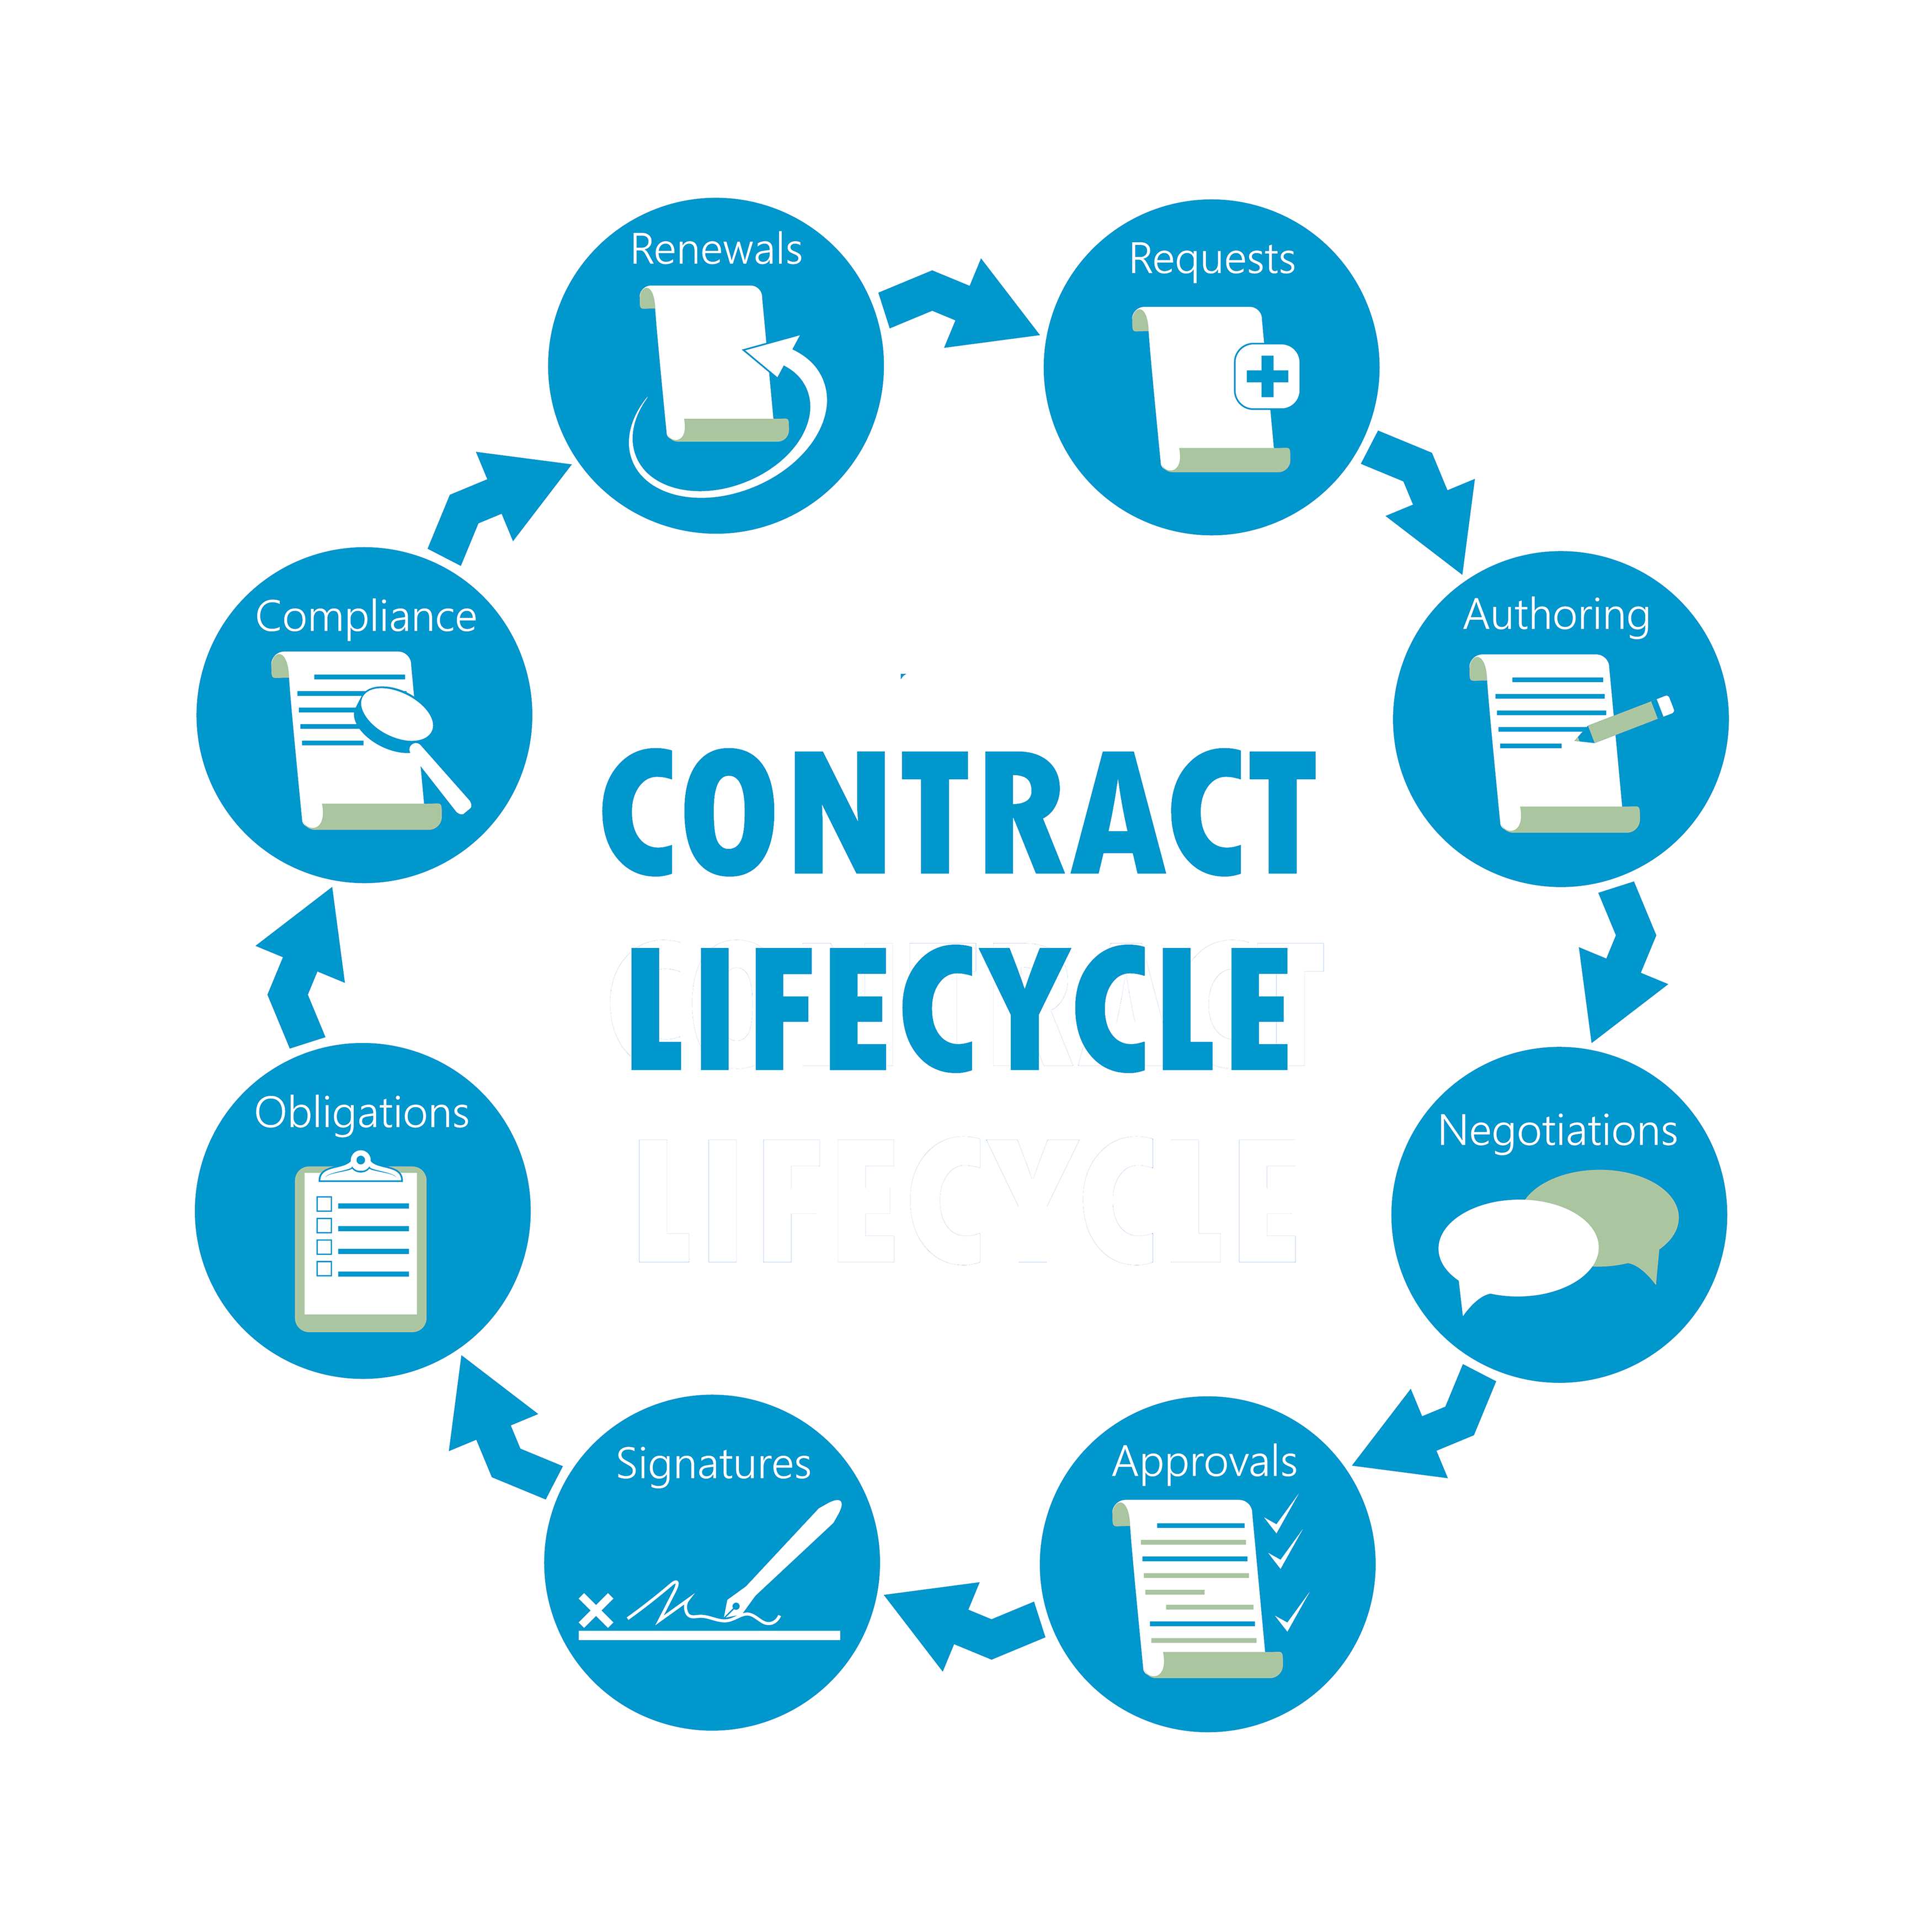
Approvals: Can you manage your approval process – with all the information you need to hand – so that you can hit all deadlines with minimum complexity?
Execution: How long does it take to get a contract signed? Are you wasting time searching for documents and versions, leading to longer draft, review and approval times?
Obligations: Once contracts are executed, can you manage your obligations and tasks without undue stress? Do you have the right monitoring tools and dashboards in place to help you assess risk, control spending and meet increasingly stringent compliance standards?
Compliance: Do you have visibility of all your contractual relationships and full audit trails? Do your reporting capabilities maintain your regulatory, legal and compliance standards?
Renewals: Will your new system enable you to manage your contract renewals effectively so that you have every opportunity to negotiate, update, or cancel?
Choose with care
With more CLM software suppliers in the marketplace than ever, your contract management team really needs to choose the supplier(s) that can best meet your organisation’s specific needs. It’s not just a case of matching user ability and offering ongoing tech support; you also need a solution that offers you the capabilities to maximise your system and can embrace the relentless march of technology as your business needs change and develop.

So your new supplier can offer you contract authoring, reporting and analytics, tracking and management, as well as tactical support of your current processes? That’s not really enough. The right choice will be more than just a CLM supplier. Ideally they’ll assume the role of a strategic partner – a partner that will work with you to understand your business needs, envisage future challenges and adapt your solution accordingly.

This is the perfect time to review the level of complexity of your contracts, your compliance requirements and process, the various contract types you use, your current contract management process and exacting legal requirements. Narrow your search down to a shortlist of 2 or 3 providers that you’re confident can provide the features and benefits you most need.

Try before you buy
Many B2B software companies offer try before you buy, but not all demos and trials are created equal. It’s true that a demo can give you a high level overview of the product and/or solution. But that may not be enough to help you make the best case for investment. Why not ask potential suppliers to set up a group demo – perhaps with the view of addressing some issues you have with your current process? And if you need to follow up with further demos that show you how the system will work with a specific set of examples your business has to manage, then the right software provider won’t hesitate to help you out.

A trial is the best opportunity you have to try out any potential software in anger. The right provider should be happy to facilitate this. At Four Business, we offer a free trial of our CMS software Contract Insight, where any potential users can use the system to address their specific needs. Throughout your free trial, our CMS experts will host work sessions and collaborate with your users to build solutions for your specific business requirements so they – and you – can get a feel of the compatibility and potential of the software – specific to your business and your requirements.


To build the case for investment in your chosen software, focus on the impact the software can make beyond your role and your departmental use. What are the strategic, long-term issues that affect your business? Compliance? Risk? Security? Identify the key personnel that will be involved in the decision. Is it the legal department, human resources, the chief financial officer, the chief operating officer, the procurement team or the compliance department? Really make your trial period work hard for you by identifying the kind of reports your decision-makers will want to see, and work with your software provider to build these samples during your trial.

Building the case – stop wasting time, money and opportunity


When building the case for your chosen contract management solution, take the time to do some in-depth research into your contracts, your current processes and your ongoing and future needs, so that you can directly translate the benefits available into the value that matters most to your stakeholders. Consider common issues around the contract management processes already in situ – whether that be manual contract management or managing contracts with disparate systems – include lost contracts, long contract cycles, increased risk, compliance issues, ineffective negotiations and approvals and missed renewals to name but a few. All of which eat away at your bottom line.

To translate the opportunity offered by contract management software into tangible value, analyse your current contracts and if you can, extract the following data:
- quantity of all contracts managed in a year
- value of all contracts managed in a year
- average value of a contract
- average contract failure rate and financial impact
- average lifecycle length
- various types of contracts managed (buy-side/sell-side) etc.
Lead your presentation with empathy
Key to your success is knowing exactly what matters most to the people who will approve your case or turn it down. How can you pitch it in such a way as to avoid any resistance and get the approval you’re looking for? This might be a business issue, but like much in life, empathy is the key to the door. If you present a success story closely aligned with the issues your decision-makers care most about, you’re much more likely to get buy-in.

When building your case, keep in mind that if you make it easy for the powers that be to see the financial benefits, time savings, process efficiency and positive impact on risk, they will understand the value of an improved contract management process as you see it.
Try to include:
- a summary of current contracts
- a resource estimate for software implementation, training, and management
- the financial benefits translated to cost savings and increased revenue
- a summary of the current contract management system’s level of efficiency, costs, and risks.


A practical guide to developing your business case
Each potential decision-maker has different roles, goals, and responsibilities. The key to your success is building your case around what matters most to them. Here are three strategies which can help:
Create a compelling message:
Be clear on what you are asking for, what the goal is and what reaching that goal entails. Align this message with business roles and priorities – depending on who is making the decision.
Communicate in their language:
If you can, use words and examples that resonate with your decision-maker’s thought processes. Do they like sports metaphors? Do they love numbers? Seek out co-workers who can help you find out the type of presentation which will get the most positive reception. Some people like bullet points and some like detail; it’s best to provide both.
Confidently face resistance:
Anticipate questions and challenges. Support your recommendation by providing the solution to clearly defined problems that you already know matter. Be ready with clear action steps and an unwavering focus on the top priorities. When possible, ask your peers and co-workers to support your endorsement.

So who do you need to impress?

The CEO with the power to say yes
CEOs are generally focused on strategy rather than function. When presenting your recommendations, be prepared to discuss the competitive advantage, the impact on strategic goals and the cost of inaction, and above all be results-oriented.

The COO driven by operational efficiency
Demonstrate how CMS will help the business take control of contracts with improved administration, task management, transparency and reporting. Highlight value in increased productivity and operational efficiency that will result in better profitability.
The CCO navigating a complex regulatory market
In an ever-evolving, complex regulatory landscape, transparency and effective reporting are critical. If your solution highlights areas of risk, enables strict adherence to regulatory requirements, protects reputation and ensures a watertight response to any legislative action, then you’re well on your way.

The Head of Sales focused on pipeline, closing and process
When presenting your case, ensure your chosen software offers revenue and sales improvement, easy negotiation and shortened contract cycles. A streamlined sales process will support and motivate sales staff.


The CFO with the power to approve purchase timing
Process automation and data analysis is important but can you demonstrate how the software can impact the business? Can it help reduce budget and business risks, and provide long-term value? Can you show the impact of the investment across the organisation or on a departmental basis? Time is the largest cost to any business and unforeseen expenditure from automatically renewing contracts one of the biggest risks. Ensure you highlight these so that financially the project is assured.

The CPO focused on procurement and supply chain transparency
Even if you’re not part of the procurement process for your specific role, if your proposed software solution can keep costs down, ensure compliance, reduce any need for legislation and increase transparency, you’re onto a winner. During your trial, ask your potential supplier to generate reports showing the value and analysis of the contract portfolio with an in-depth view of contracts.

The CIO focused on digital transformation and security
What impact will the new software will have on customer experience, cyber-security and compliance? Ideally your software will support improved data management in a secure environment, consolidate legacy applications and integrate easily with other systems that need access to contract data with minimal IT intervention.

Legal department focused on legal recommendations and business strategy
If you focus on how contract management software supports document assembly, and reduces the amount of time spent drafting and reviewing documents, bringing more visibility with contract reports and analytics – this will land for legal.
Getting stakeholders on board
If you collaborate with your preferred supplier to identify challenges before they impact, and show value from the initial purchase decision, you’ll be well-placed to fully leverage all the benefits CMS can offer. Involving all the stakeholders from the beginning with your supplier selection will make them more likely to respond positively to your selection.
Research internally to find out what departmental systems are in place to determine how your recommended solution can be used across individual departments as well as connecting the contract eco-system across the organisation. Be sure to present a story to stakeholders which can demonstrate exactly how the CMS will improve every stage of the contract lifecycle.

To sum up…
Making a case for contract management software is most effective when you consider the bigger picture. Can you demonstrate the potential value of contracts supported by leading technology that automates contract lifecycle management – against their current value? If so, you’ll be able to create a convincing case structured around a compelling message in the language of all the stakeholders that you need to improve your investment.
Contract Insight from Four
Contract Insight is a cloud-hosted (SaaS) or deployed (on-premise) contract management solution. The acclaimed platform is trusted by thousands of professionals for their contract management, legal document management, procurement and sourcing needs. Used by many multinational and smaller local companies, Contract Insight gives you real time visibility into your contracts. It doesn’t just shore up your security – it will help you meet contract compliance regulations, centralise your contract management and improve your overall contract administration process.

For more information on Contract Insight from Four, on how to better manage and secure your business, or if you would like a free trial, please contact:
John OBrien, Director, Four Business Solutions , john.obrien@four.co.uk , 0800 6250 025.

Shaun Cassidy, author of this white paper is the Technical Director at Four Business Solutions, global business consultants and software integrators providing business processes improvements in Finance, Supply Chain & Operations, across a broad range of industries.

